Lab 11 manual: Mathematical pendulum oscillations
Dr. D. Beznosko
6/28/2022
For PHYS 1111L and PHYS 2212L
(Lab outcomes: Study of non-linear effects using force sensors and Capstone software [1].)

Abstract
This experiment allows to compare angular frequency for the mathematical pendulum that is launched at different angles to study the deviation from the small-angle approximation. The $χ^{2}$ method are used to obtain the fit probability to the model. Other software fitter use is allowed. The consequences of the linear approximation validity are discussed.

Introduction
The Newton’s second law is most known $F=ma$ equation. From it, the equation for the oscillating motion comes. The mathematical pendulum is a case of a general oscillating motion. How and where do we see oscillators every day?
The use of the force sensor and the protractor allow for the data collection and analysis in the Capstone software that also provides the errors on the fit parameters but lacks $χ^{2}$.
For additional information on the pendulum behavior, you may refer to the following site: https://en.m.wikipedia.org/wiki/Pendulum_(mechanics) or a local copy.

Experimental Setup

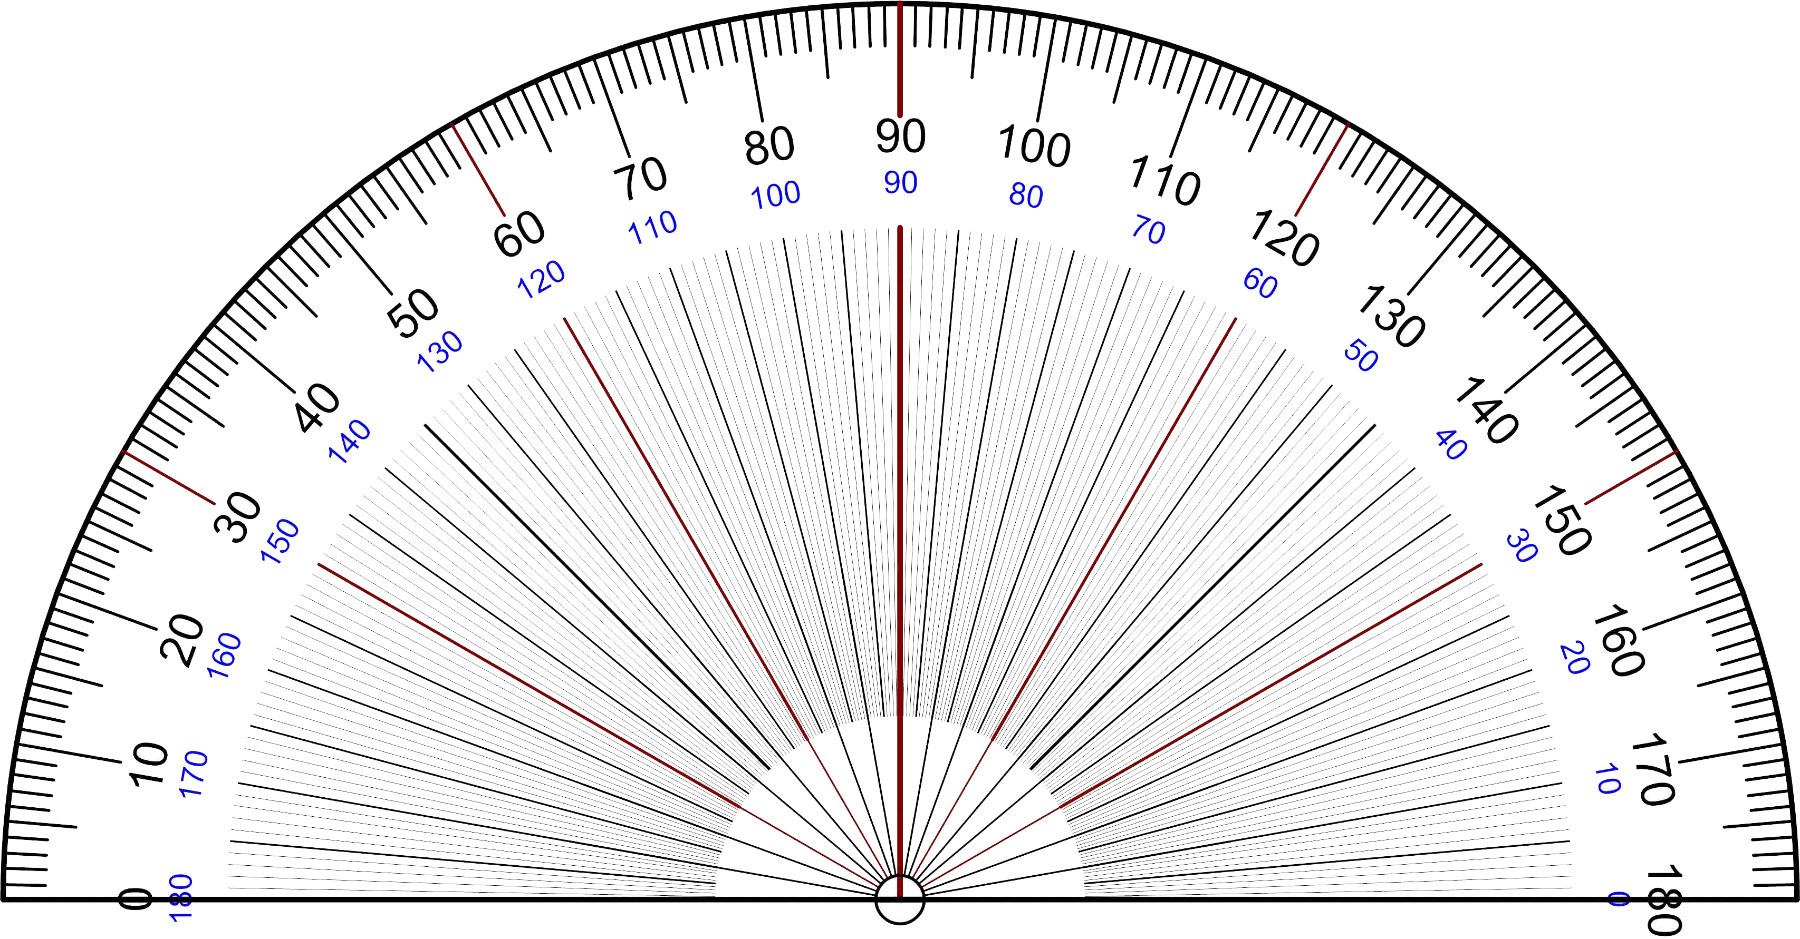
An experimental setup schematic is shown in Figure 1 and includes the force sensor (Figure 1a) and the mass on a string (Figure 1b). The sensor is connected to a computer for readout. Protractor is used to measure the oscillation angle (Figure 1c).
Figure 1: The experimental setup schematic. A force sensor (a) is used to measure the force exerted by the oscillating mass (b). Protractor (c) is used to measure the angles.
a)
b)
c)
mass

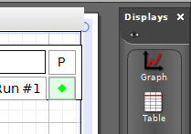
Procedure
Do we need to weigh the mass? If you think so, start by weighing the mass. What is the error for this measurement? Hint - use lab 3 result! Measure the pendulum length!
Make sure that the force sensor is connected and it’s showing the Force vs time plot in the Capstone software. You may need to create one clickin gon the Graph and dragging it into the central area of the program screen as usual.
Do a test run. Zero the force sensor first (push the button or in settings). Move the mass so that the string will make about 20-degree angle with the vertical and let it oscillate. Start the data acquisition and collect several full oscillations. From the fit functions, choose the Sine function that should read $Asin\left(ωt+ϕ\right)+c$: that is the function that is able to fit the recorded data. Use the data selection tool (yellow pensil with blue dots). Select several oscillations with it. Change the selection – move it, make it smaller or larger. See how the $ω$ changes. Do that 5 times, the stdev is the systematic error. You can re-use this value for all measurements. The error from the fit is the statistical error and it may change for different measurements.
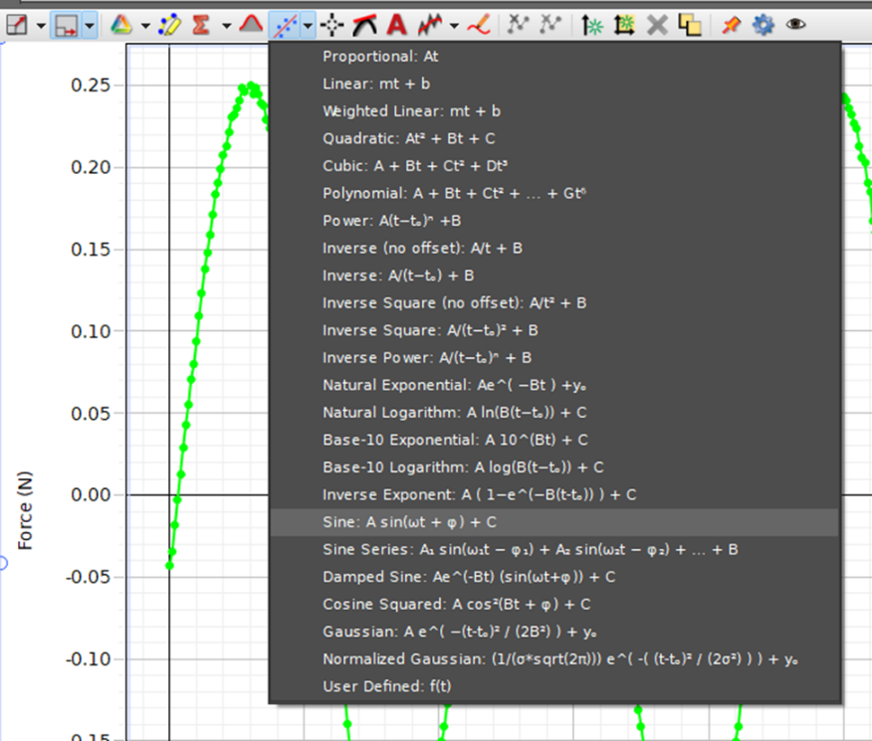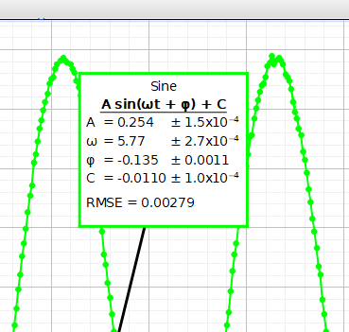

Figure 2: The highlighted part of data and the Mean and Standard deviation values.
Delete the old data and get ready for the real run. Do a total of 10 runs. Each run should be started from different angles – 5, 10, 15, 20, 25, 30, 35, 40, 45 and 50 degrees. After each run, fit the data and save the $ω$ and its error. (Hint: Start recording after several oscillations so that the mass stabilizes. Also – for better fit you might need to select several full oscillations using the select data tool. Does the angle change at the end of your measurements? Use as error?)
Write the angles, corresponding omegas and errors in a spreadsheet and save it.
Close the Capstone program and don’t save the file if the program asks you to do so.

Experimental Data
Organize the results of the measurements in tables such as Table 1. The error can be listed in a different column (this is more convenient if copied from Excel), or as value ± error unit. In the description of how the data was obtained, include a screenshot or a photo of the Capstone program with data and fit (only one, for illustration only!)
Table 1: Experimental data sample table.
Angle, degrees | Angular velocity, rad/s

Provide a description about each entry or table as needed, don’t just leave the table without text in this section. Organize well so that data takes less space, but everything needed is included.

Theory
Newton’s second law is re-written for the pendulum and is given here as the differential equation in eq. 1. PHYS2211L ONLY: students should highlight how eq. 1 can be derived from Newton’s 2nd law for the pendulum of length $l$ in a few steps.
$$\frac{d^{2}}{dt^{2}}θ=\frac{g}{l}sin\left(θ\right)\left(1\right)$$
where $l$ is the pendulum length from the pivot point to the center of mass, and $θ$ is the angle between equilibrium position and at maximum amplitude. Normally, as this equation has no simple analytic solution, a small angle approximation is used: for angles below about 15 degrees, $sin\left(θ\right)=θ$ when the angle is expressed in radians. This leads to a well-known solution:
$$θ\left(t\right)=Asin\left(ωt+ϕ\right)\left(2\right)$$
with $ω$ being the angular velocity and $ϕ$ is the starting phase. Few other equations we will need to use are: $ω=2πf∧T=\frac{1}{f}$. Here, $f$ is frequency and $T$ is the period of the oscillations. However, if the pendulum is launched from the larger and larger angles, the period will change in a non-linear fashion as in Figure 3. You also need the equation for T for the small angle approximation case.
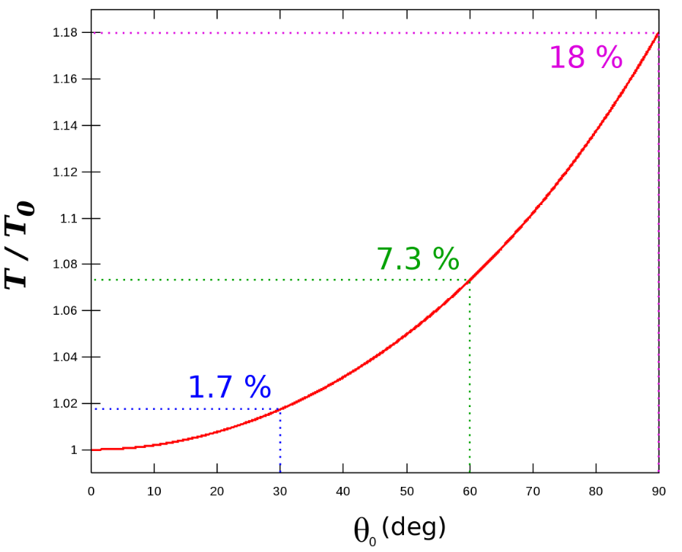
Figure 3: Non-linear behavior of pendulum period $T$ at large angles.
While this is the solution of the elliptical integral of first kind that is beyond the introductory physics level, we can use the following approximation:
$$T≈T_{0}\sec^{2}\left(\frac{θ}{4}\right)≈T_{0}\left(1+\frac{θ^{2}}{16}\right)\left(3\right)$$
The part that is denoted $T_{0}$ is the period from the small-angle approximation. We are not interested in solving and using this equation further, what we want is a quadratic relationship.

Analysis
The goal of this lab is to show the quadratic nature of relationship from equation 3 to be true. Sometimes, this is also called a quadratic correction term.
For the error on angle, estimate the simple error from your use of the protractor. For the $ω$, the error comes from the fit. Propagate the error from $ωT$ – you will need to derive the equation for $T$from$ω$. Use provided equations! (Hint: You can average all errors for omega and use this common value for all angles.). PHYS1111L use the simplified equations and PHYS 2211L must use the partial derivative – now you have the error for $T$. Do this for all omegas.
Plot the period T vs the angle (in degrees or radians). Include all error bars. Add a 2nd degree polynomial trendline. Find the $χ^{2}$. What is the probability that this line fits your data? (Use the online calculator to convert $χ^{2}$ to probability, such as https://www.di-mgt.com.au/chisquare-calculator.html. (use left side probability) NOTE: the website asks you to enter the degrees of freedom and the $χ^{2}$ that is NOT reduced – i.e., not divided by degrees of freedom.!!!).
T is max
T is min
T is min
Where is the $T_{0}$ in your fit? What does it represent? Compare with the theoretical value that uses small angle approximation.
Now, you may find here that the theoretical value is twice the measured one. No panic – think about how we measured the $ω$: we looked at the changes in the force, which is the tension in the string. Per one period, there are two maximums in the tension. So, what we measure is ${T_{0}}/2$ and not the full period.

Conclusion
Discuss the results. Your $χ^{2}$ value shows how your model line fits the data as well as the probability. Does that support equation 3? Any other thoughts and comments?

References

[1] | PASCO Scientific, 10101 Foothills Boulevard, Roseville, California 95747 USA.

